Exercise and Physical Activities at home following discharge from Intensive Care Unit
Many patients who have been through the intensive care unit during their hospital stay often experience deconditioning. Deconditioning refers to a physical and/or psychological decline in function. Prolonged bed rest and inactivity can affect nearly all systems of the body. The person feels weak, tired and exhausted after little or no effort. Many described that they unable to get their energy back even after resting and experience a lot of fatigue. This can affect their ability to get back to their usual activities when they are discharged from hospital.
Therapy input and support are usually provided during the stay in hospital. Some patients required further stay on the specialist rehabilitation where they are provide with additional therapy input before discharge from hospital. Irrespective where they are located in the hospital, most patients are seen by a physical therapist. They can evaluate the person and work to strengthen and stretch the muscles and tendons that are most in need. The purpose is to strengthen the weakest muscles without overworking the opposing muscles. When the body is in balance, the patient will be much better and able to progress in exercising.
Some patients still require ongoing therapy and support even after discharge from hospital. They are usually referred to the community services within their locality. Sometimes there is an unavoidable gap of a couple of weeks before these community services are able to provide the necessary therapy input required. If no activity is carried out in this period after discharge, there is a risk that many patients may become further deconditioned during the period of waiting for community therapy services. It is essential that you continue to perform the exercises you were provided with at discharge. They are equally as important as the medications that you are been provided with. Deconditioning happens to people of all ages for many different reasons. It can happen also in people who have not been treated in an intensive care unit. It can occur in various conditions and can occur after a brief period of being unwell depending on your level of physical fitness. Even young people can be caught in this trap after a serious accident, broken bones or a serious illness.
Many people are actually able to do a lot of activities on their own that will further help in their recovery and rehabilitation. Depending on their ability and level of support they can get from family/carers, there are various physical activity programmes that can be performed in the period of waiting for the community therapy services to provide additional input. In this leaflet, we have described some activities and exercises that you might want to perform. These activities are mainly advisory and do not replace any specific rehabilitation or therapy programme that you might be required to attend that are peculiar to your own condition or diagnosis. The advice and treatment plan from your specialist still remains paramount and in the event that any of the suggested activity or exercise contradicts the instructions from your specialist, please seek clarification before implementing the exercise.
The treatment of deconditioning is to become conditioned. This is usually achieved through conditioning exercises. Any activity is better than nothing. Every effort must be made to move muscles, limbs or body parts that you are able to control regularly. The point of conditioning exercises is to start where you are and gradually work your way toward a fit body. It may take weeks, months or years and in some cases the person may never get to full fitness. The alternative is further deconditioning, even to the point of becoming bedridden. For the elderly that can mean a sentence of pneumonia and death.
Deconditioning is a serious problem in many exercise routines because a much deconditioned person will sweat profusely and may become dangerously shaky when participating in only a few minutes of regular exercise, even tai chi or walking. A person in this condition needs to start slow, with as much support at hand as possible.
Sitting Exercises
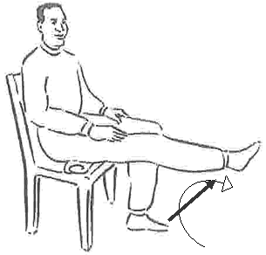
Most people can nearly always begin chair exercises. These will have been started by the therapists while you were in hospital and are a good way for you to gradually regain control by starting with chair based exercises. Each person is different and some people would have advanced well beyond this stage by the time they are discharged from hospital. It is however a good starting point to ensure that activities are commenced in a safe mode. Your therapist would have given some specific recommendations of programs that will be just right for you.
By sitting, the person will have good support and there will be no danger of falling that will create an even worse conditioning problem. There are many good DVDs and video tapes for chair exercises, usually marketed for seniors but everyone who is beginning their fitness journey from square one can use them.
Look for products that have a variety of types of exercise to appeal to your interests, abilities and to prevent boredom. Be sure that the chair used is wide and strong enough to hold you securely even when you shift around while exercising. A fall is the last thing a person needs.
Try the following categories and look for other no-impact exercises and products. Some of these products might be available at your local library to check out to use at home for free. It will let the person try an exercise for free to see it they like it.
•Chair yoga
•Chair tai chi
•Stretching exercises, using stretch bands
•Core fitness programs
•Seated chair dancing
•Strength training
Moving Up
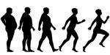
Once a person can do 30 minutes or so of chair exercises and they end up nicely winded but not gasping for air or sweating profusely, you can move up. Keep up the chair exercises; don’t stop.
If the person has good balance, they can add walking with someone walking alongside them in case of balance issues. If you have been provide with a mobility aid such as a frame, walker, crutches or walking stick then it is essential that they are used to provide safety and security.
Some people are unable to walk and might require a wheelchair for their mobility. In this instance, perfecting their transfer technique to achieve independence or consistency in transfers might be the starting goal. Getting out of bed into the chair on daily basis and sitting out for increasing period of time to improve tolerance will also help with conditioning.
A trip to the end of the driveway or about 25 feet (7.5 metres) can be the next goal, for example. Then, three trips half that distance, then progress to four or five trips without stopping. Move up a half-distance at a time. At first, it may be smart to put a chair on both ends of the course.
Move up the distance gradually. This stage may take quite a while and a person may never reach a very significant goal. Even if a very sick or elderly person can eventually walk 50 feet (15 metres) without stopping that is enough mobility to keep them active enough to ward off further illness such as pneumonia and death.

Pool Exercises Are Next



Those who can move on can take advantage of pool exercises. These are still no-impact but they do take a certain level of conditioning to participate. The water provides not only joint protection but lessens the body weight of the exerciser. The water also provides resistance to increase muscle strength while exercising. Most local authority and council pools provide aqua aerobics/fit sessions including designated sessions for those with mobility restrictions. These special sessions often have staffs that are trained in delivering input for people with medical conditions. It is worthwhile to contact your local leisure centre for more information on the sessions they run.
Finally, once the chair exercises and pool exercise programs can be easily completed, it might be time to move on to gym based exercises to complete your fitness journey. It is important that you are evaluated by a physical therapist or a doctor to get approval to moving on to this stage. A few patients are able to commence their re-enablement activities at this stage after discharge from hospital. They are able to join a health club to complete their fitness journey. Each person is different and it is important to work to your own individualised schedule.

The Final Push
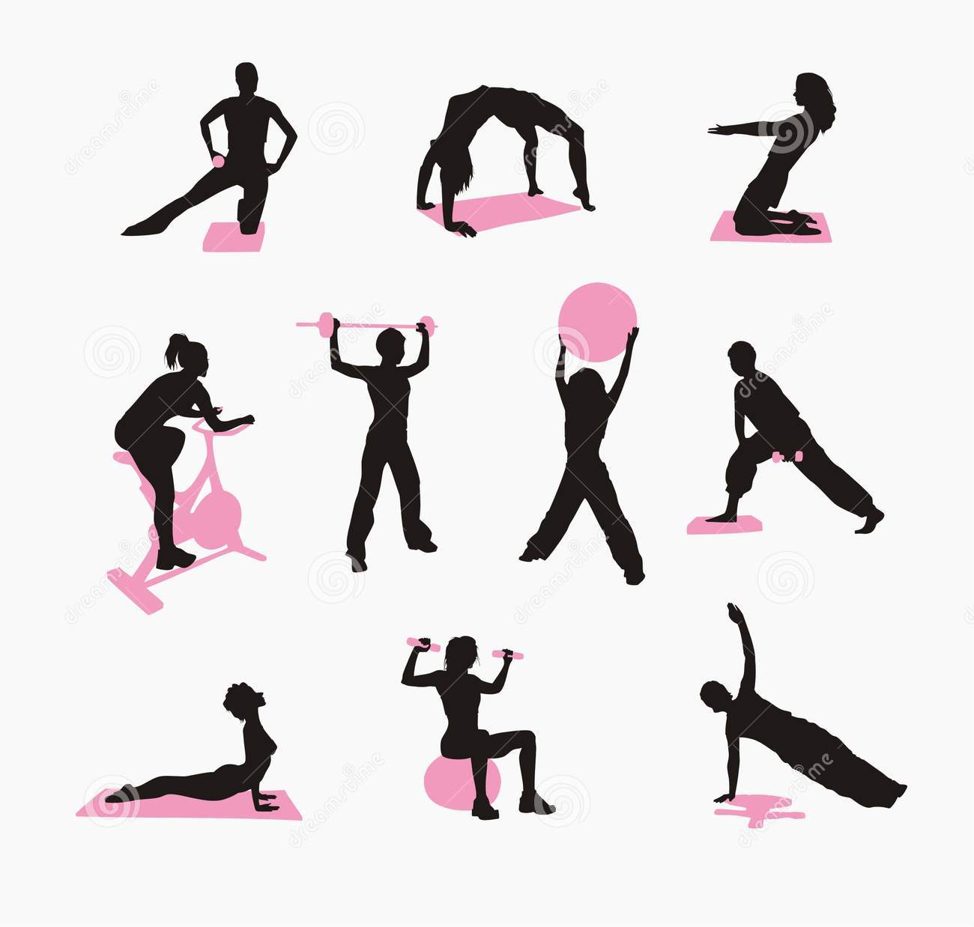
The trainers at a community based gym can continue working with you on specific areas and toward general body health. They will stay with the patient, making sure that he or she can catch the client in an off-balance moment. The trainer will also make sure that each exercise is completed correctly without further injury. (If you are from Hull area, I would recommend attending the Age UK Healthy Living Centre located at Bradbury House on Porter Street. They offer innovative activities with ground breaking facilities and have sessions for people both over and under 50 years of age. Additionally, the community musculoskeletal physical therapy service runs regular clinic sessions in this facility). It might be beneficial at this stage to invest in an exercise heart rate monitor that can be used to set the intensity of your exercise and physical activity programmes.
There are many other organisations and charities that offer various activities and support within each locality. Most village and religious centre halls offer a variety of activities that cater for people with various levels of needs. It is worthwhile to contact any of these organisations to find out what is available within your area. It is of paramount importance to remain active even after returning to your previous level of activities. It is worthwhile to know that many physically fit people do not achieve the recommended weekly level of 150 minutes of moderate physical activity. So your usual level of activities might not have been enough to maintain fitness and give you extra reserve to cope with the health situation you have just been through. This period, as challenging as it is, can be utilised to spur you to greater heights.
By continuing an active lifestyle, working out regularly at the health club, walking and participating in movement exercises like stair climbing through the day, a person who was deconditioned can become healthy and fit again. There is now an ever increasing evidence base of the health benefits from taking part in regular physical activities.
Dr Abayomi Salawu
Consultant in Rehabilitation Medicine

